- Coal is mines in Collie, in the south-west of Western Australia. The coalfield was discovered in 1880’s, and mining began in the 1890s.
- What are two geophysical methods of exploration that could be used to discover a new coal resource? (10 marks total)
For each of these:
- State and describe the method (3 marks)
- Provide evidence that might indicate that coal was present. (2 marks)
Feel free to use a diagram to support your answer.
Method one: ________________________________________________________________
Description of method: ________________________________________________________
___________________________________________________________________________
___________________________________________________________________________
___________________________________________________________________________
Evidence of coal: _____________________________________________________________
___________________________________________________________________________
___________________________________________________________________________
___________________________________________________________________________

Method two: ________________________________________________________________
Description of method: ________________________________________________________
___________________________________________________________________________
___________________________________________________________________________
___________________________________________________________________________
Evidence of coal: _____________________________________________________________
___________________________________________________________________________
___________________________________________________________________________
___________________________________________________________________________

- Explain why using a magnetic survey exploration method would not be suitable for identifying a coal resource. (3 marks)
___________________________________________________________________________
___________________________________________________________________________
___________________________________________________________________________
___________________________________________________________________________
___________________________________________________________________________
___________________________________________________________________________

- Describe how you could use a geochemical sampling technique to identify a more precise location of the coal resource. (5 marks)
Feel free to use diagrams to support your answer
___________________________________________________________________________
___________________________________________________________________________
___________________________________________________________________________
___________________________________________________________________________
___________________________________________________________________________
___________________________________________________________________________
___________________________________________________________________________
___________________________________________________________________________
___________________________________________________________________________
___________________________________________________________________________
___________________________________________________________________________
___________________________________________________________________________

- Describe the process of surface mining and when it is appropriate to use (4 marks)
___________________________________________________________________________
___________________________________________________________________________
___________________________________________________________________________
___________________________________________________________________________
___________________________________________________________________________
___________________________________________________________________________

- Describe the process of underground mining and when it is appropriate to use (4 marks)
___________________________________________________________________________
___________________________________________________________________________
___________________________________________________________________________
___________________________________________________________________________
___________________________________________________________________________
___________________________________________________________________________
___________________________________________________________________________

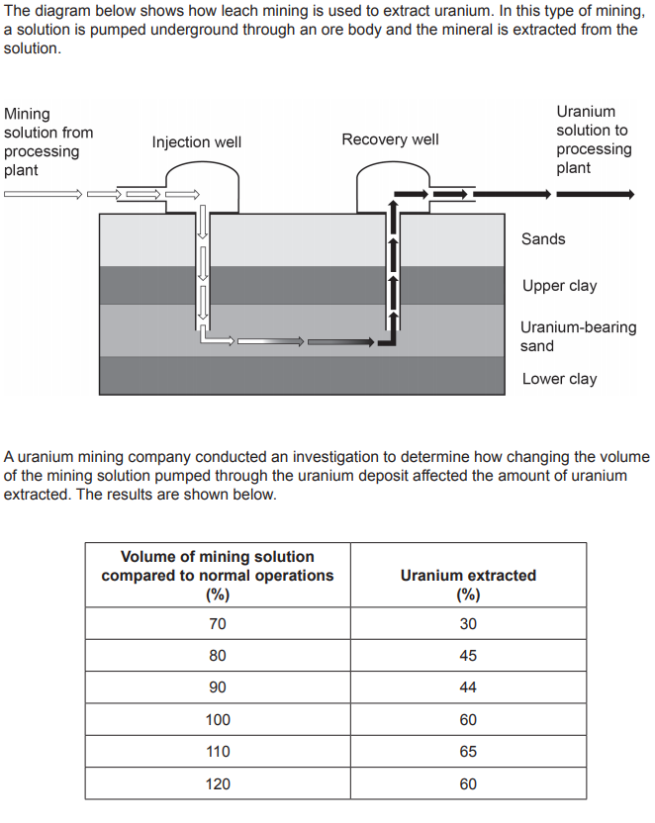
- Identify the following variables for the investigation (4 marks)
- Independent: _______________________________________________________
- Dependent: ________________________________________________________
- Two controlled variables: ______________________________________________
- Draw a line graph of the results for this investigation (5 marks)


Using the data, recommend and justify the volume of mining solution that the company should use in order to extract the most uranium (2 marks)
___________________________________________________________________________
___________________________________________________________________________
___________________________________________________________________________

